AWS RDS Read Replicas

# RDS Read Replicas Overview

* Read replicas enable increased scalability and database availability in the case of an AZ failure.
* Read Replicas allow elastic scaling beyond the capacity constraints of a single DB instance for read-heavy database workloads
* RDS read replicas can be Multi-AZ i.e. set up with their own standby instances in a different AZ.
* Load on the source DB instance can be reduced by routing read queries from applications to the Read Replica.
* one or more replicas of a given source DB Instance and serve high-volume application read traffic from multiple copies of your data, thereby increasing aggregate read throughput.
* Read replicas can also be promoted when needed to become standalone DB instances.
* RDS uses DB engines’ built-in replication functionality to create a special type of DB instance called a Read Replica from a source DB instance. It uses the engines’ native **asynchronous replication** to update the read replica whenever there is a change to the source DB instance.
* Read replicas are available in RDS for MySQL, MariaDB, PostgreSQL, Oracle, and SQL Server as well as Aurora.
* RDS supports replication between an RDS MySQL or MariaDB DB instance and a MySQL or MariaDB instance that is external to RDS using Binary Log File Position or  Global Transaction Identifiers (GTIDs) replication.

## Read Replicas creation

* **Up to five Read Replicas** can be created from one source DB instance.
* Creation process
  + **Automatic backups must be enabled** on the source DB instance by setting the backup retention period to a value other than 0
  + Existing DB instance needs to be specified as the source.
  + RDS takes a snapshot of the source instance and creates a read-only instance from the snapshot.
  + RDS then uses the **asynchronous replication** method for the DB engine to update the Read Replica for any changes to the source DB instance.

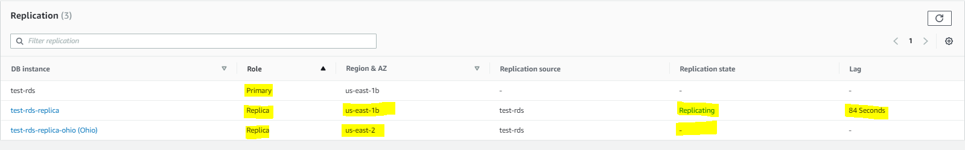

* RDS replicates all databases in the source DB instance.
* RDS sets up a secure communications channel between the source DB instance and the Read Replica, if that Read Replica is in a different AWS region from the DB instance.
* RDS establishes any AWS security configurations, such as adding security group entries, needed to enable the secure channel.
* During the Read Replica creation, a brief I/O suspension on the source DB instance can be experienced as the DB snapshot occurs.
* **I/O suspension typically lasts about one minute and can be avoided if the source DB instance is a Multi-AZ deployment (in the case of Multi-AZ deployments, DB snapshots are taken from the standby)**.
* Read Replica creation time can be slow if any long-running transactions are being executed and should wait for completion
* For multiple Read Replicas created in parallel from the same source DB instance, only one snapshot is taken at the start of the first create action.
* A Read Replica can be promoted to a new independent source DB, in which case the replication link is broken between the Read Replica and the source DB.  However, the replication continues for other replicas using the original source DB as the replication source.



* When you promote a Read Replica, replication is stopped and the Read Replica is rebooted as part of the promotion. In addition, the promotion process is irreversible and you cannot restart the replication with the promoted DB Instance as a replication target.

## Read Replica Deletion & DB Failover

* Read Replicas must be explicitly deleted, using the same mechanisms for deleting a DB instance.
* If the source DB instance is deleted without deleting the replicas, each replica is promoted to a stand-alone, single-AZ DB instance.
* **If the source instance of a Multi-AZ deployment fails over to the standby, any associated Read Replicas are switched to use the secondary as their replication source.**

## Read Replica Storage & Compute requirements

* A Read Replica, by default, is created with the same storage type as the source DB instance.
* For replication to operate effectively, each Read Replica should have the same amount of compute & storage resources as the source DB instance.
* Source DB instance, if scaled, Read Replicas should be scaled accordingly

## Cross-Region Read Replicas

* Supported for MySQL, PostgreSQL, MariaDB and Oracle
* **Not supported for SQL Server**
* helps to improve
  + disaster recovery capabilities (reduces RTO and RPO),
  + scale read operations into a region closer to end users,
  + migration from a data center in one region to another region
* A source DB instance can have cross-Region read replicas in multiple AWS Regions.
* Cross-Region RDS read replica can be created from a source RDS DB instance that is not a read replica of another RDS DB instance.
* Replica lags are higher for Cross-region replicas. This lag time comes from the longer network channels between regional data centers.
* RDS can’t guarantee more than five cross-Region read replica instances, due to the limit on the number of access control list (ACL) entries for a VPC
* Read replica uses the default DB parameter group and default security group for the specified DB engine.
* Deleting the source for a cross-Region read replica will result in
  + read replica promotion for MariaDB, MySQL, and Oracle DB instances
  + no read replica promotion for PostgreSQL DB instances and the replication status of the read replica is set to terminated.

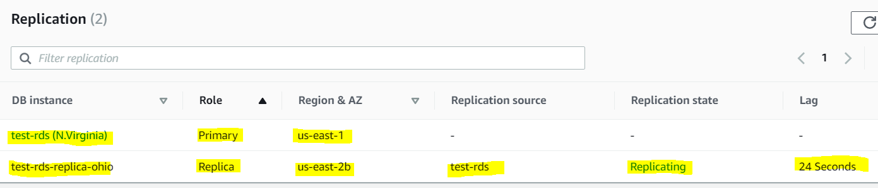

## Read Replica Features & Limitations

* RDS does not support circular replication.
* DB instance cannot be configured to serve as a replication source for an existing DB instance; a new Read Replica can be created only from an existing DB instance for e.g., if MyDBInstance replicates to ReadReplica1, ReadReplica1 can’t be configured to replicate back to MyDBInstance.  From ReadReplica1, only a new Read Replica can be created, such as ReadRep2.
* Read Replica can be created from other Read replicas as well. However, the replica lag is higher for these instances and there cannot be more than four instances involved in a replication chain.



### 

### Read Replica Use cases

* Scaling beyond the compute or I/O capacity of a single DB instance for read-heavy database workloads, directing excess read traffic to Read Replica(s)
* Serving read traffic while the source DB instance is unavailable for e.g. If the source DB instance cannot take I/O requests due to backups I/O suspension or scheduled maintenance, the read traffic can be directed to the Read Replica(s). **However, the data might be stale.**
* Business reporting or data warehousing scenarios where business reporting queries can be executed against a Read Replica, rather than the primary, production DB instance.
* Implementing disaster recovery by promoting the read replica to a standalone instance as a disaster recovery solution, if the primary DB instance fails.